TTH, Inc.’s Accomplishments of 2022


- TTH currently provides 440 individuals with housing including 112 permanently affordable rentals and 92 ownership homes in trust. TTH stands in solidarity with BIPOC community members to fight for racial equity in housing. With 36% of TTH owners and renters identifying as BIPOC, TTH is committed to increasing equitable housing opportunities, leadership representation, and safe spaces for all.

- TTH has expanded the Community Land Trust and property management reach to Baldwin City, and soon Eudora, Kansas. Gold Leaf Senior Living hosts 24 fully accessible senior housing units. These, along with three new construction units in Baldwin City, officially establishes TTH as a County-wide provider of affordable housing.

- TTH continues its stewardship and co-fiscal sponsorship of the Housing Stabilization Collaborative (HSC). Since its inception in 2020, the HSC has been allocated over $2,000,000 in recovery funds to serve 745 households with over $1,292,212 in rent support distributed to date. This Douglas County partnership, led by a program manager, continues to strengthen bonds between housing agencies, the housing insecure, and participating landlords.

- TTH received 100K in Housing Trust Fund dollars in 2021 to bring privately owned vacant and underutilized homes into the affordable rental market. Working with the City of Lawrence and private owners, ARM is bringing previously vacant units into good standing by making basic repairs and stewarding these rehabilitated affordable rentals. In 2021, TTH went under contract with two unique properties to add a total of 19 bedrooms to Lawrence’s affordable housing market. At a time when affordable housing supply is at an all-time shortage, ARM is allowing TTH to responsibly expedite and increase the number of available affordable units.

- With masks on, TTH completed 7 real estate transactions, making 15 people new homeowners and adding 4 new homes to trust. TTH’s 7 sales had an average market value of $168,285. The average subsidy per home was $46,000 plus closing costs of $4,000, allowing income eligible families to have an average affordable price of only $122,100. The Lawrence Board of Realtors reports the average 2021 sale price was $294,591, up 14.2% from the previous year. LCHT homes—including 3 brand new (one with a solar panel) —were purchased for $172,591 below the average sale price in Lawrence—TRULY AFFORDABLE!

- TTH successfully launched Reciprocity Microloans in August of 2021. Developed as a pilot program to provide low-interest (2%) “micro” loans, Reciprocity is an alternative to predatory lending that prioritizes single caregivers, and persons with marginalized identities earning at or below 60% of Average Median Income. 5 microloans in the amount of $1,000 were awarded and dispersed with a repayment term of 24-36 months. Depending on outcomes, the program may grow in 2022 to offer a second and third round of microloans.
- TTH’s Helping Hammer Senior Home Repair Program provided sliding-scale home repairs to 26 Douglas County senior households including consultation, accessibility improvements, and general maintenance.

- TTH partnered with Housing and Credit Counseling, Inc. to provide 3 online workshops. We were excited to resume in-person engagement with 1 September workshop for a total of 4 workshops educating 22 potential buyers. 35 pre-qualifying sessions helped buyers with LCHT financing and credit counseling.

- Restoration House, Phoenix House, and 6 Maine homes provide transitional and permanent housing with care coordination for survivors of domestic violence and young adults aging out of foster care. This year, TTH and Willow housed 26 survivors, ensuring they did not have to choose between violence and homelessness.

- TTH received $609,000 in grants and donations from 52 different supporters in 2021, including a $100,000 donation to support the development of small housing.

- TTH, in partnership with Habitat for Humanity, Douglas County, and the cities of Baldwin and Eudora are constructing affordable homes using a $400,000 state Moderate Income Housing (MIH) Grant. When completed, this project will allow TTH and Habitat to put 10 houses in trust in Baldwin City and Eudora. Currently, the first of three new construction homes is nearing completion and will sell to a family from a waiting list of qualified Baldwin City buyers in early 2022. These will be our first trust homes outside the city limits of Lawrence. We are excited to work with our neighbors to meet their specific affordable housing needs and provide homebuyer education classes beginning in 2022.
- TTH completed its second home on a single lot in the Brook Creek neighborhood. This marks the first use of the City of Lawrence ordinance allowing increased density for permanently affordable single-family housing. Completion and sale of this home has finalized the small community of three houses on two lots, all with footprints less than 800 square feet. This home, 1443 Prairie (aka Solar Prairie) received an Elizabeth Schultz Environmental Fund grant from Douglas County Community Foundation in 2020 and is the first affordable home in Lawrence to feature solar energy. An energy audit issued a HERS score of 26, one of the most energy efficient HERS scores issued to a new construction home in the City of Lawrence to date! Solar Prairie is estimated to have total annual energy cost of $467. This means monthly housing costs (mortgage, insurance, taxes, and utilities) are $200 less than the Lawrence Fair Market Rent for a 2-bedroom apartment
—Truly Transformational!

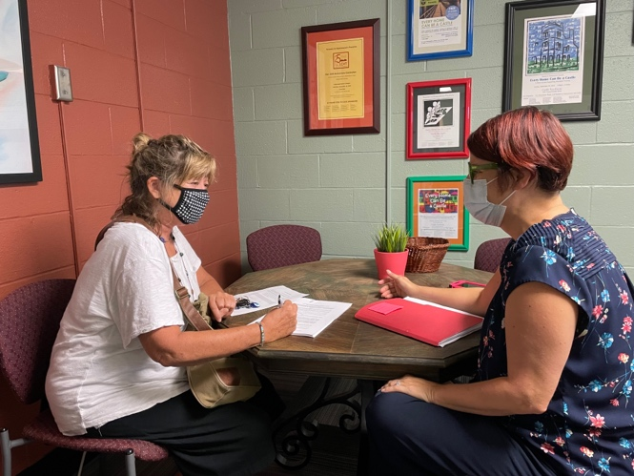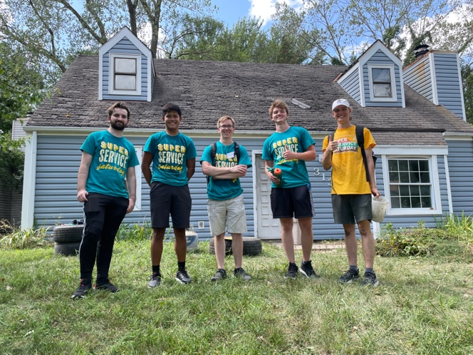
Contract signing for the new homeowner of Solar Prairie KU volunteers ready to help clean out an ARM property

Stay informed and check out our website at
www.tenants-to-homeowners.org
or our Facebook page—Tenants to Homeowners, Inc.

