**TTH, Inc.’s Accom­­­­plishments of 2023**

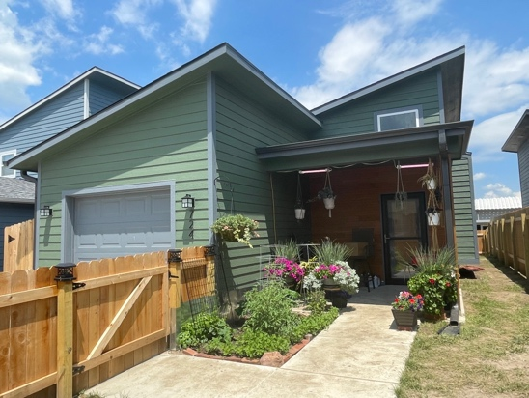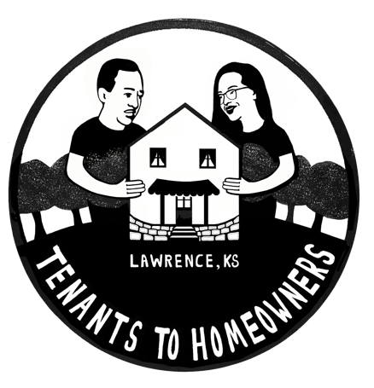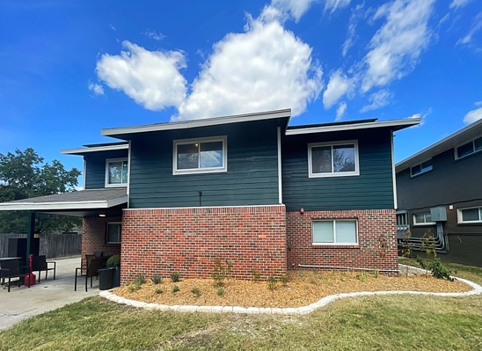

* TTH currently provides **465** individuals with housing including **134** permanently affordable rentals and **104** ownership homes in trust. TTH stands in solidarity with BIPOC community members to fight for racial equity in housing. With **36.3%** of TTH owners and renters identifying as BIPOC, TTH is committed to increasing equitable housing opportunities, leadership representation, and safe spaces for all.

.

* In 202**3**, TTH completed **6** real estate transactions adding **5** new homes to trust.TTH’s sales had an average market value of **$204,000**. The average subsidy per home was **$66,333** plus closing costs of **$4,000**, allowing income eligible families to have an average affordable price of only **$130,000.** The Lawrence Board of Realtors reports the average 2023 sale price was **$303,100**, with homes selling for an average of 100% of their listed sales price. LCHT homes—including **3** brand new (with solar panels) —were purchased for an average of **$173,100** below the average sale price in Lawrence—**TRULY AFFORDABLE!**
* TTH continued to form programming complete with wrap around care for supportive service housing units at Sunrise House. Sunrise’s makeover was completed this year and an open house for the community happened on September 8, 2023. During 2023, all supportive service housing units housed **95** individuals (63 households) transitioning from or preventing houselessness. **Sunrise House** specifically served **25** individuals. During the year, many tenants were connected to additional services, allowing **15 (60%) to still be housed** with TTH or other stable options. One person at Sunrise House celebrated a year of housing after almost 20 years of being houseless. Wrap around services and partnerships with community providers are key!
* **Phoenix House**, an affordable supportive service home with 3 units for young adults aging out of the foster care system, housed **6** youth in 2023 and provided supports that helped these young adults acquire independent living skills that will enable them to become self-sustaining.
* TTH’s **Helping Hammer Senior Home Repair Program** provided sliding-scale home repairs to **26** Douglas County households including consultation, accessibility improvements, and general maintenance.
* TTH was excited to provide **5** in-person workshops at the Lawrence Public Library, educating **67** potential buyers. **29** pre-qualifying sessions helped buyers with LCHT financing and credit counseling.
* **Restoration House** and **6 Maine homes** provide supportive and transitional housing with care coordination for survivors of domestic violence and their children. This year, TTH and Willow housed **13 households including 24 survivors**, ensuring they did not have to choose between violence and homelessness.
* TTH received over **1 million** in grants and donations from **30** different supporters in 2023 and held a successful annual event that included a Corn Hole Tournament partnering with Free State Baggers.
* TTH started construction at 1718 Harper- A bedroom neighborhood with 1 remodeled home and 6 new construction homes all situated on 1 acre of land. Utilizing the affordable density bonus ordinance has allowed TTH to keep the purchase prices down for our buyers, even as we fight the rising cost of construction and increased interest rates. All new construction has a focus on energy efficiency, including solar panels to help reduce monthly utility costs. 1718 Harper will provide 7 new units in trust, including the first to be added on 12.27.23!
* TTH continues its commitment to energy efficiency by including solar panels on our next 6 two-bedroom units at 1718 Harper. With support from the Elizabeth Schultz Environmental Fund and the Douglas County Community Foundation, our first home at Beatnik Court to feature solar received a HERS score of 28! This is one of the most energy-efficient scores issued to a new construction home in the City of Lawrence to date! Beatnik homes­­ featuring solar are estimated to yield a total **annual energy cost of less than $500**. This means monthly housing costs (mortgage, insurance, taxes, and utilities) are equal to or less than the Lawrence Fair Market Rent for a 2-bedroom apartment—**Truly Transformational!**
* TTH started new partnerships in 2023 to increase our capacity to build new units. These partnerships include:

1. a building program with Peaslee Technical Institute, where trade school students get practical building experience while creating small units at affordable prices.
2. Similarly, a partnership with Dirtworks Studio, a KU Architecture design-build studio, is allowing us to experiment with different building materials while keeping costs affordable due to architecture student labor and donations from material sponsors. This is a win-win for teaching the next generation of architects about affordable design and creating affordable supply.
3. Finally, the Limestone Elementary School’s 1st and 2nd graders wanted to explore the problem of housing supply for those experiencing houselessness. They worked with architects from Multistudio to design some simple units that TTH will build. One of these is for one of their teachers who is eligible and on the waiting list for our homeownership program. This partnership is getting national attention and helping us remind people about the need for workforce housing for our teachers and social workers, as well as those who are experiencing houselessness. The need is great, and TTH is expanding its capacity to meet the need in **3** creative ways!

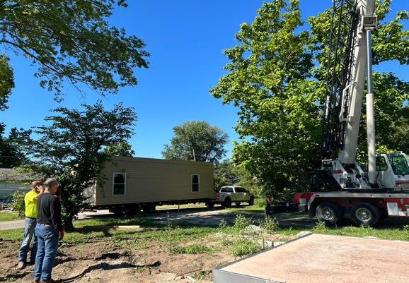 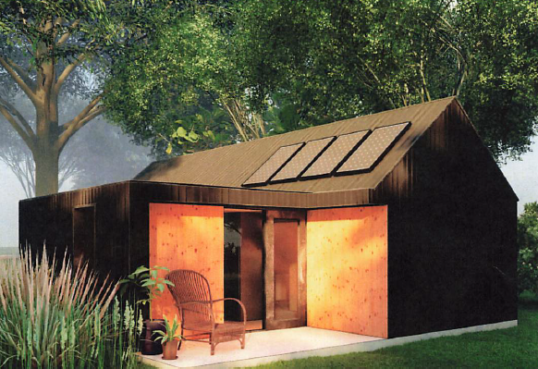   
  
Stay informed and check out our website at [**www.tenants-to-homeowners.org**](http://www.tenants-to-homeowners.org)  
or our Facebook page—Tenants to Homeowners, Inc.